EX NO:5 ONLINE COURSE RESERVATION SYSTEM
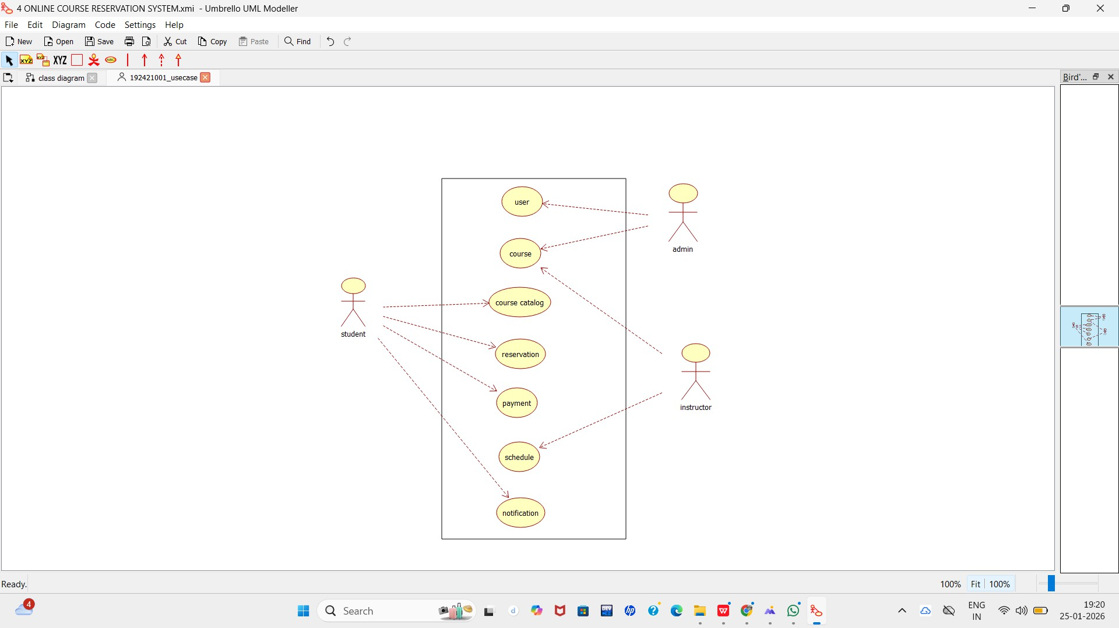
Use case

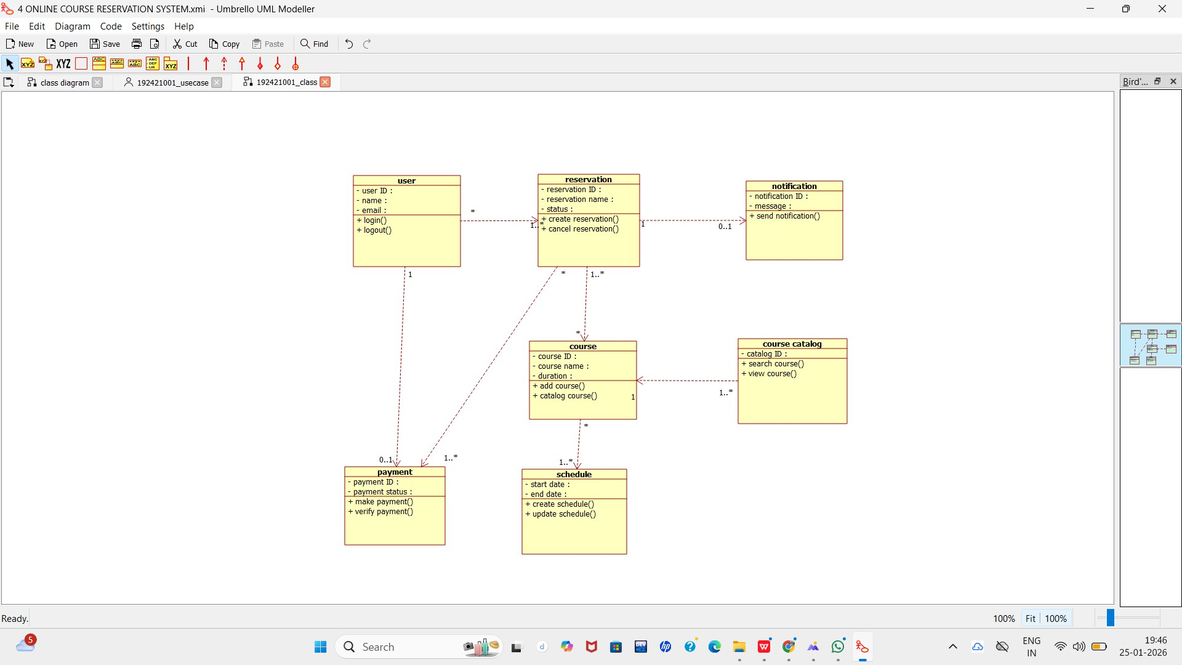
class diagram

ACTIVITY DIAGRAM:

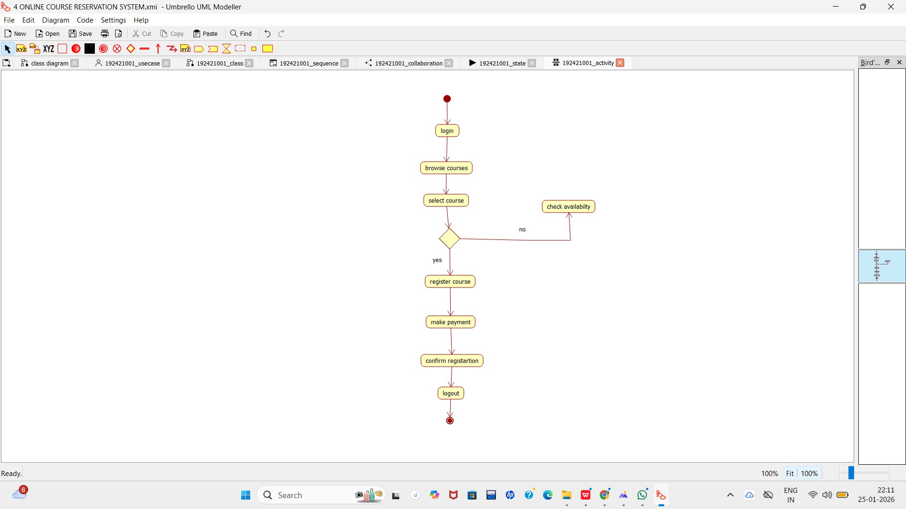

SEQUENCE DIAGRAM:
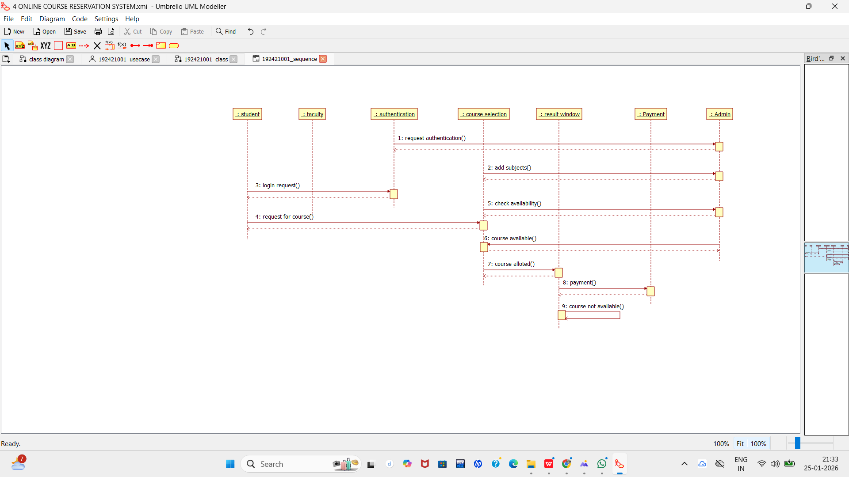

COLLABORATION DIAGRAM:

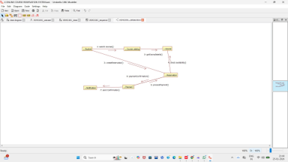

STATE CHART DIAGRAM:
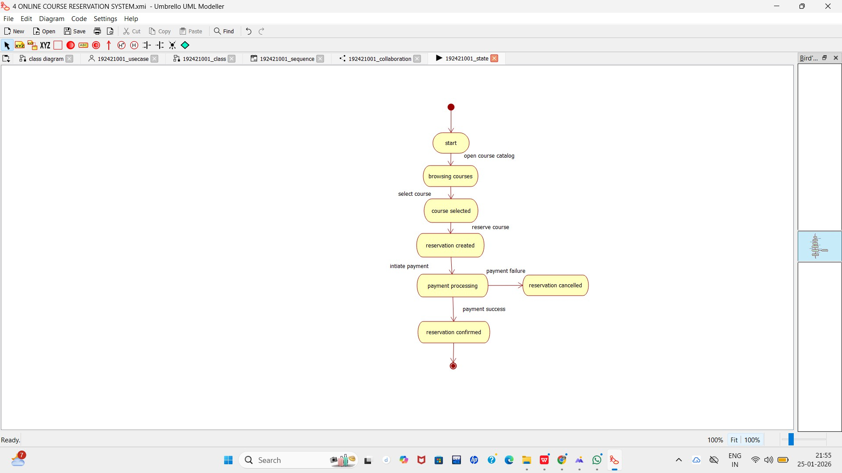

COMPONENT DIAGRAM:

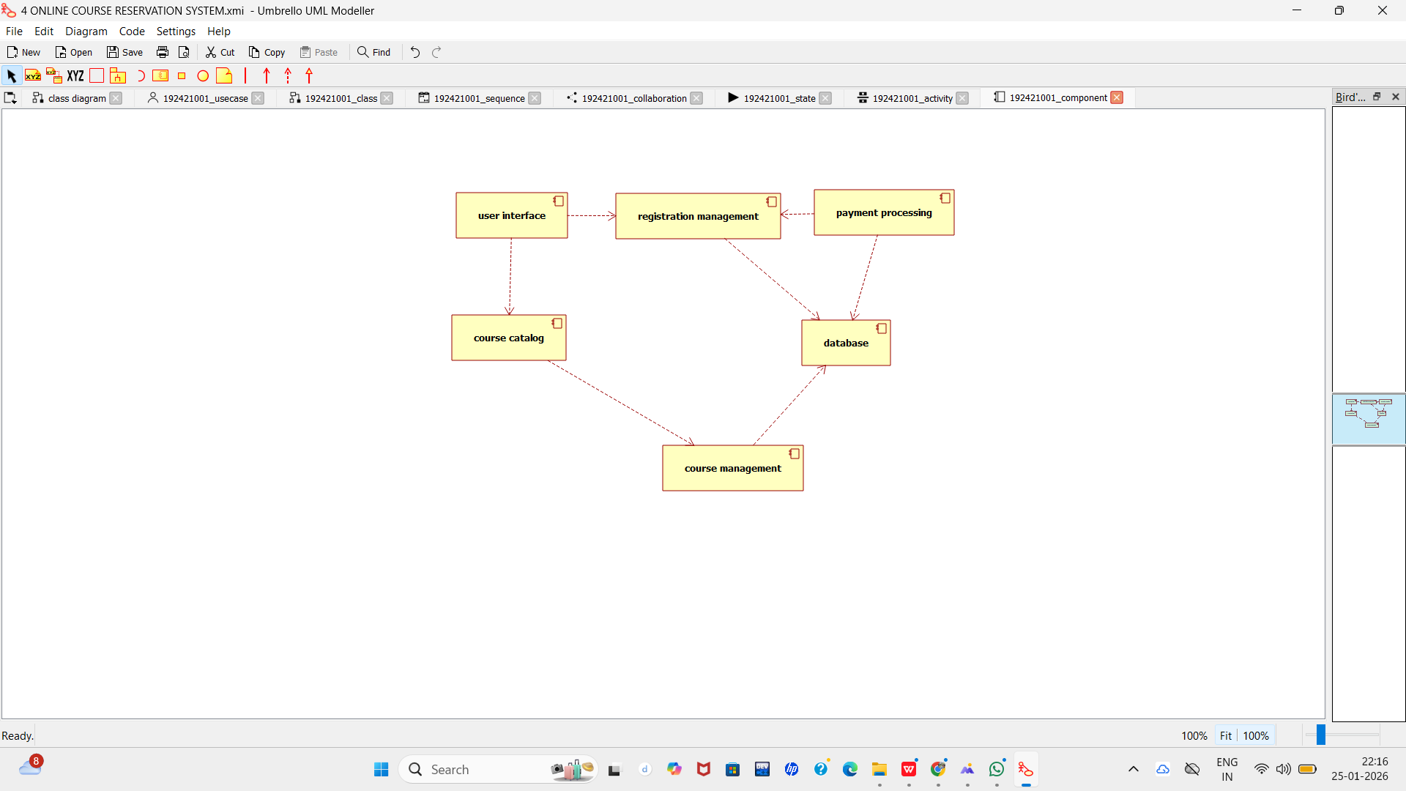

DEPLOYMENT DIAGRAM:

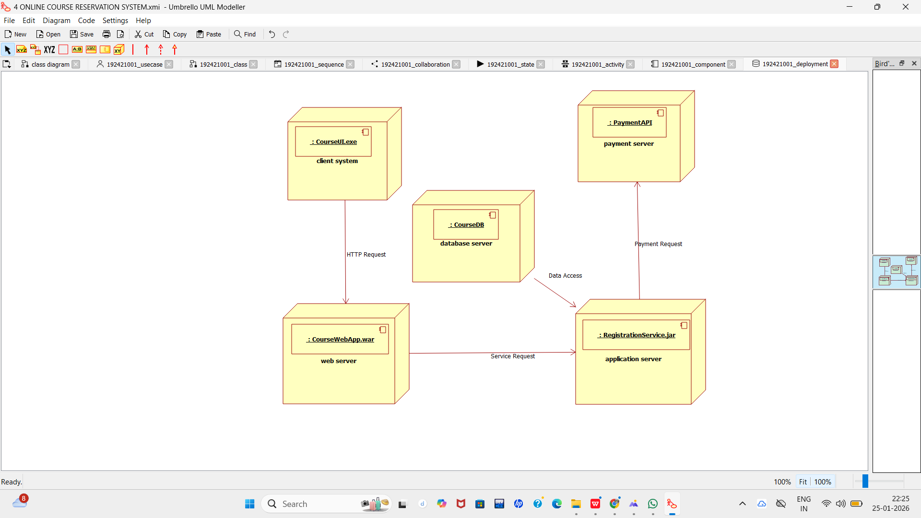

PACKAGE DIAGRAM:
